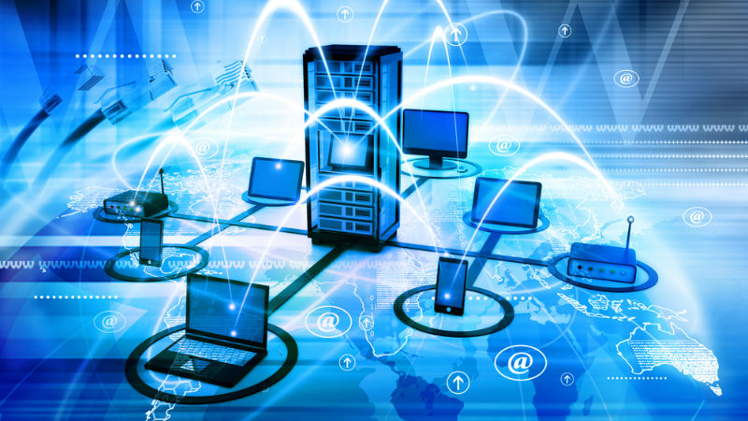

CMPG315 GROUP 30 NETWORKS

Network Topology and Packet Tracer

**Armand de Beer 31640060**

**Llewellyn Anthony 32969694**

**Ilze Weldon 30418550**

**Hlulani Rikhotso 30657830**

**Juan-Luke Klopper 32002432**

**2021/05/14**

Table of Contents

1. Group and Project Details 2

1.1 List of participating group members 2

1.2 Overview of Project 2

1.3 The goals of ABC Electronics 2

2. Network Topology and Setup 3

2.1. Overview of Topology 3

2.2. Core Infrastructure 3

2.3. Multifunction Office space 4

2.4. Support Office 4

2.5. Reception 5

2.6. Additional Features 5

3. Network Design 6

3.1. Design of the Reception 7

3.2. Design of the Core Infrastructure 7

3.3. Design of the Multi-office 9

3.4. Design of the Support office 12

4. Handling of Remote Connection 13

Remote access 13

5. Remote Group Work 15

5.1. Meetings and communication 15

5.2. Reflection on Remote Group work experiences 23

6. Budget 24

References 28

# Group and Project Details

## 1.1 List of participating group members

The following members participated in completing the project and it is the opinion of the members of this group that they all deserve to be included as equal contribution members:

|  |  |  |
| --- | --- | --- |
| Role | Name | Student Number |
| Designed Network Topology  IP configurations  Implemented Access restrictions, access logs and server backups  Documentation | Armand de Beer | 31640060 |
| VPN setups  Intrusion Detection  Documentation | Juan-Luke Klopper | 32002432 |
| Version Control on Github  Record keeping of Proof of Communication  Documentation  Internet Connection Setup | Llewellyn Anthony | 32969694 |
| Research on budget of the network, Budget calculations, cabling arrangements in Packet Tracer  Documentation | Ilze Weldon | 30418550 |
| Documentation  Description of Topology  Network Topology Screenshots  Video Editing | Hlulani Rikhotso | 30657830 |

## 1.2 Overview of Project

We are approached by ABC Accounting firm, which is a company that offers services like auditing and accounting for emerging businesses. The problem that ABC Accounting firm encountered is, they are using traditional methods to store important financial tasks. The company requires us to build a network that is going to support 3 office rooms. We must build a network that must be able to handle in-office work and work-at-home remotely. This network must be robust and affordable. The network must have a high reliable internet connection.

## 1.3 The goals of ABC Electronics

* Build a network that accommodates at least 100 people
* Build a network that can be accessed remotely (work from home).
* The network must support 3 main buildings, namely: a multifunction office space that is able to accommodate at least 100 people having wireless internet access. The second room must be a Support Office. Lastly, there must be a Reception
* A network that has office-side backup
* Each section/venue must have internet connectivity (wireless and cable)
* Each venue must have remote access data
* Each section in the network is to be isolated (the reception computer mustn’t be able to communicate with the management computer)
* Build a robust and yet affordable network for ABC Accounting firm
* Printers in each section must be accessible in their own section

# Network Topology and Setup

## Overview of Topology

When designing our network we made use of the star topology. The benefits when using a star topology is that even if one of the offices(subnet) is in need of maintenance it is only that specific section that will be disconnected from the network and the rest of the network can function as before without any interruptions. By making use of a router instead of a switch in the middle we reduced the network traffic significantly because a router can block access to certain sections and allow access to others while if it were a switch then it would not have been possible.

## Core Infrastructure

The network core infrastructure refers to all the components of the network that interact with each other allowing effective and efficient communication between the office users, applications and devices. This room houses the servers, the switches and routers and the security of ABC Accounting Firm.

* Servers

The servers in our network store and supply information to other computers in the LAN. These servers provide, store, and distribute programs and other resources to computers in the network. It also provides file backups and one is for the internet’s server.

### The backup Server

The backup servers in the network aids data, application, file and database backup. The server backup we used in the network is capable of managing and recovering files and storing the data in a remote area. The backup server is responsible for managing and recovering data.

* The Virtual Private Network

The VPN used in this network encrypts data while it travels from one computer to another or another part of the internet while securing and hiding the IP address of the computer it was sent from. This allows ABC Accounting firm to send and surf the internet privately and securely. Without the VPN in our network, the internet traffic of the company is exposed which puts the company at threat of data breaches. Here are some advantages of using a VPN server in the network: Prevents potential threats, prevents hackers from tracking the IP address of the computer the data was transmitted from.

### Switches and Routers

The main reason behind our switches is to connect all the computers in the network. We managed to connect 3 switches in the multifunction office. These switches have a function of receiving data from the connected computers in the network and send the data to the suitable end of line destination.  
We have used wireless routers in our network which receives and sends network data in packets among connected computers. These Routers are then connected to the switches. The network has multiple routers to provide wireless connection in the different rooms/sections of the network.

## Multifunction Office space

This workspace is used to host in-office work, meetings and presentations to clients that require services from ABC Electronics. In this space there must be more than 20 permanent PCs. We used wireless routers to provide fast wireless internet access which may connect remote mobile devices like tablets, laptops and smartphones (any mobile device).

## Support Office

The Support Office houses the HR & Admin, the manager’s office and IT.  
In the HR & Admin office, there must be high reliable internet connection (wireless in our case) of internet access. The network capacity must be expandable such that it can accommodate 2 – 4 people.  
The Manager’s office has 1 permanent PC and a printer that the manager can use.   
The IT section has a high-speed internet connection that is reliable at all times. The routers in this room are unique to the room such that it is dedicated to the room alone. This room also has a permanent PC which is used as a core infrastructure access.

## Reception

The reception in our network has wireless connection provided by a router. We have a permanent personal computer that is connected to a printer in the room.

## Additional Features

### Restricted access

Access restrictions are implemented when only the IT Office is allowed to transfer files to the server that allows them to backup files to Server1_LOGS&BACKUP. If the file is backed up successfully then it will show under FTP inside the services tab in the server. The FTP service will be an exclusive to the IT Office.

### Access logs

The AAA service on Server1_LOGS&BACKUP must be enabled and all the offices must be able to make use of the AAA service. The user setup must contain the login credentials for each employee’s pc. So that every time an employee login with their login credentials onto the network Server1_LOGS&BACKUP will log all of the login attempts under AAA Accounting. The employee’s will login via the command prompt in their desktop then they will type the following: telnet 192.168.1.1 this IP address is the default gateway of Server1_LOGS&BACKUP.

### Network firewall

The firewall was supposed to be between the router that connects to the switch that goes to the internet and the router. The firewall purpose is to block any threats to the network that may arise from the internet.

### Traffic management

Traffic management will be done on the routers. The routers will manage the traffic through making use of static routing; this will allow that packets to be blocked from being sent to offices they don’t have access to and allow them to be sent to their destinations that they are allowed to communicate with.

### Backups

Only the IT Office will be allowed to make backups on the Server1_LOGS&BACKUP. This can be done via the pc’s command prompt via the following command: ftp 192.168.1.2 the IP address here is the IP of Server1_LOGS&BACKUP. The login with the following credentials: username- group30_IT and password- $group_30$ once that is done you just specify the file you want to upload to the server. The file can be viewed on Server1_LOGS&BACKUP then FTP under Services.

### Intrusion detection system

The intrusion detection system is done on the router in the server room that connects to the internet. The purpose of the intrusion detection system is that it will alert the network if there are incoming packets of data to the network that may be harmful to the network or sent from unauthorized devices. Which means that it may be any sort of virus,worm or malware that tried to make its way into the network will be flagged. If this were to happen an message will appear on Server1_LOGS&BACKUP under syslog under the services tab there it will show the IP address of the intrusion.

### Internet

Within the star topology, there is one centralized server that provides Internet Connection to all the other client devices. All devices in the topology can access the domain ABC.com. The DNS for the domain ABC.com is configured as 208.67.220.220.

# Network Design

In this section the physical network design is shown. This is the floorplan of the network:

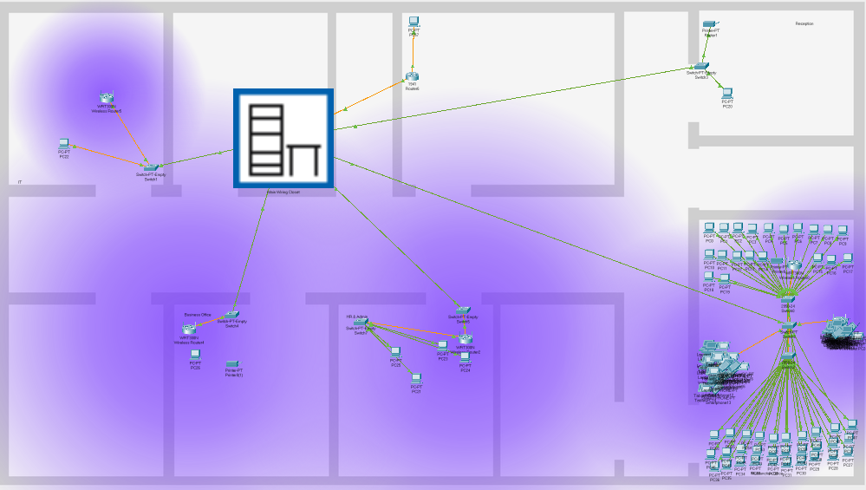

## Design of the Reception

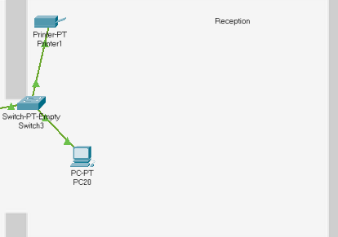 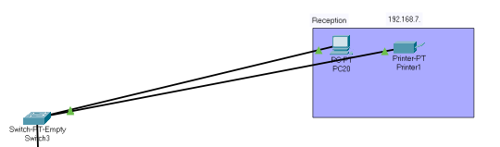

## Design of the Core Infrastructure

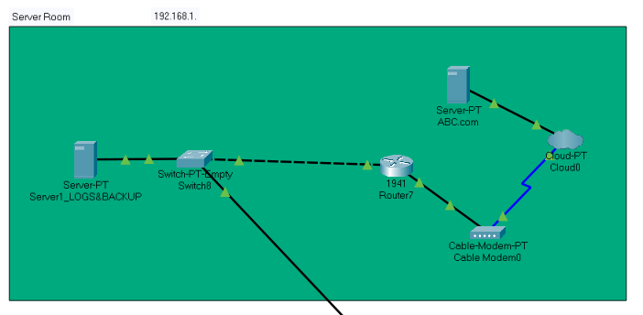

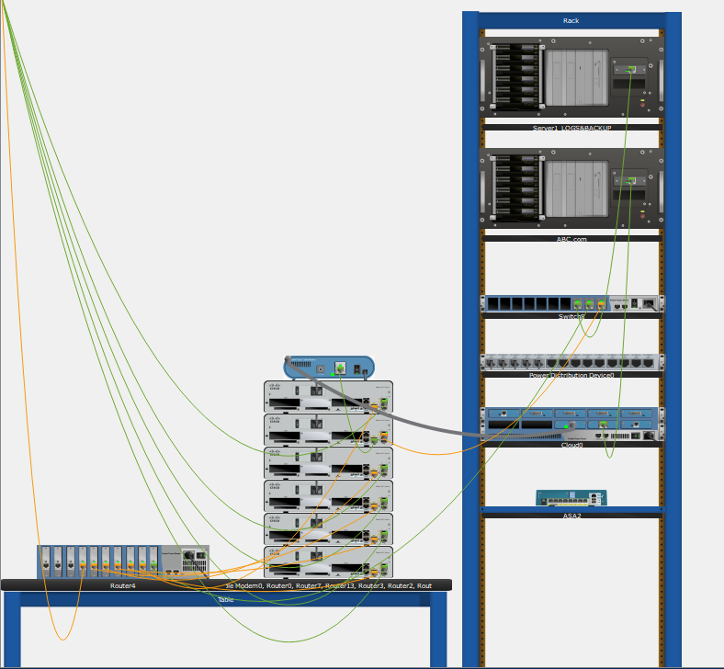

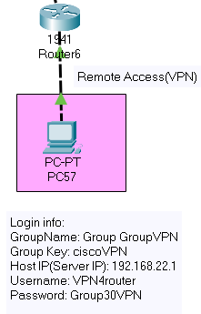

## Design of the Multi-office

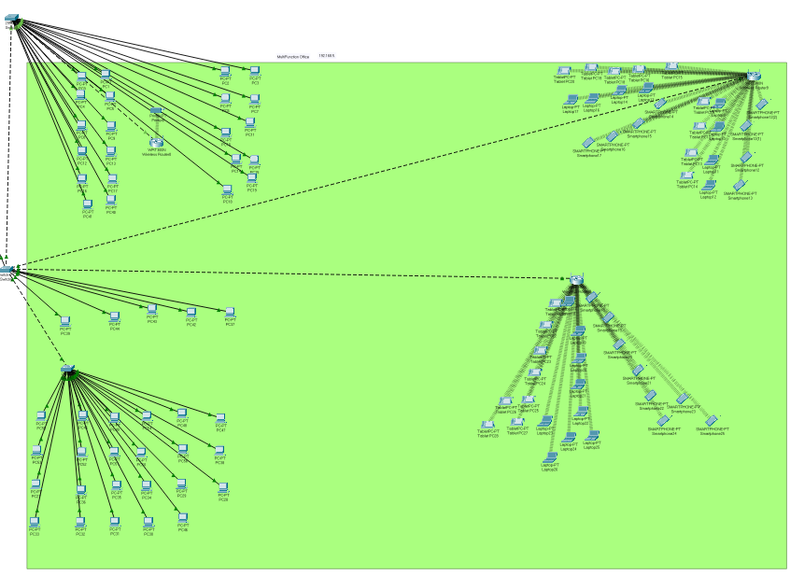 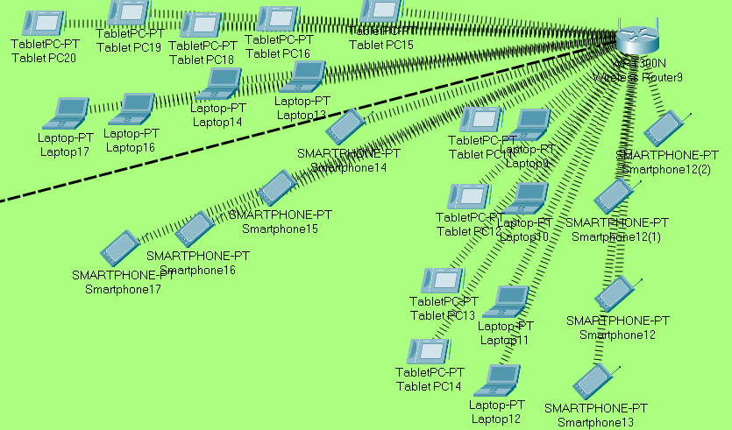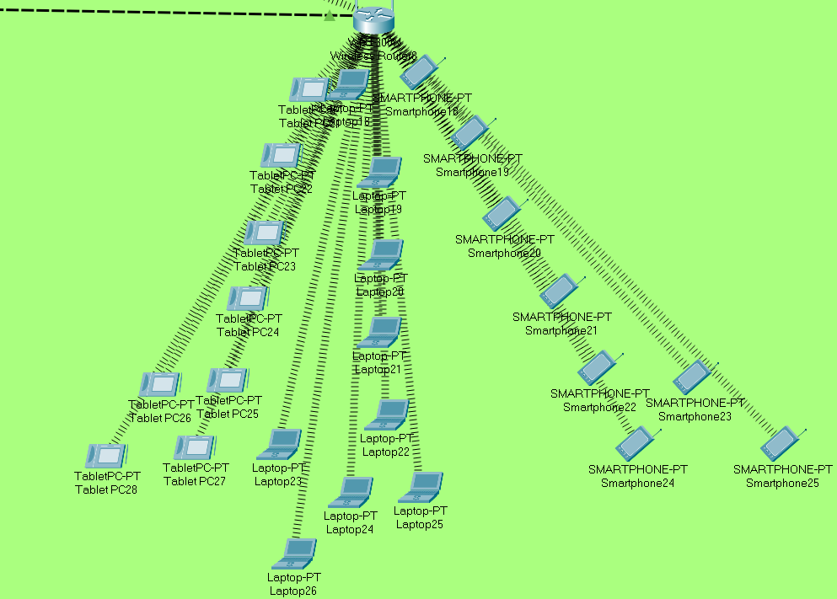 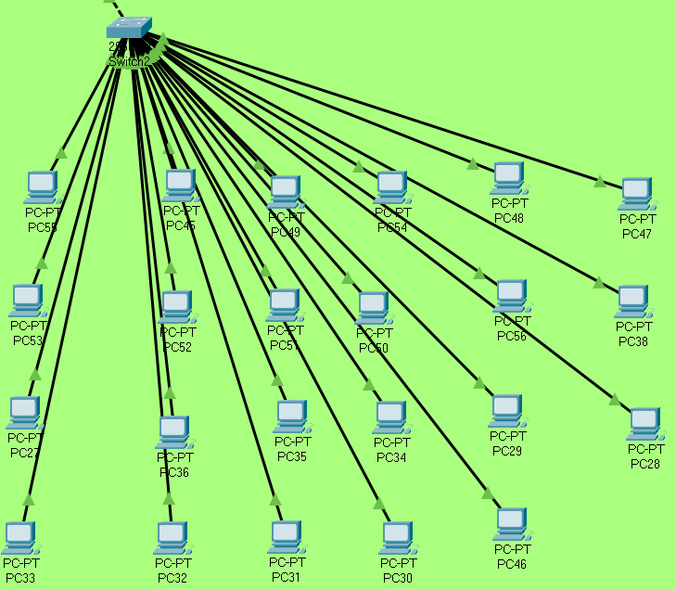 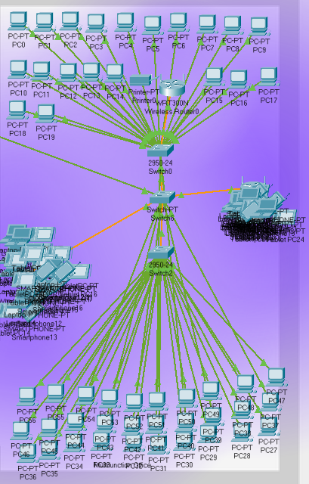

## Design of the Support office

The support office consists of 3 sections namely, the IT, the HR & Admin and the Management section.

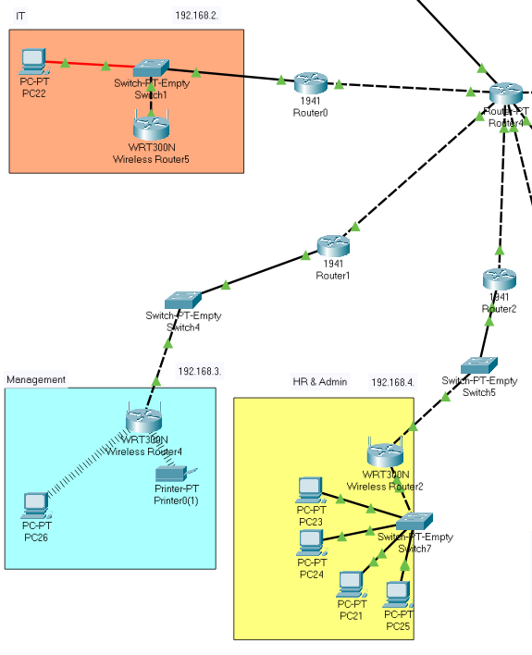

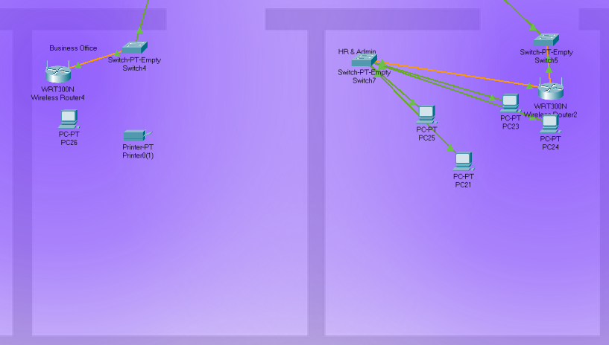 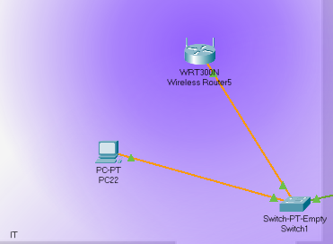

# Handling of Remote Connection

## Remote access

The network is capable of offering access via remote connection through the use of a virtual private network or VPN. This allows for the following features to be offered to the stakeholders:

Office workers can remotely connect to the office intranet. This means the business can now employ people from anywhere in the world as they only need an internet connection and the login credentials to then use the office network as if they are inside the office. The VPN will greatly reduce the risk of security breaches and cyber attacks as all data is encrypted using a military-grade encryption algorithm called AES-256. The VPN encourages productivity as workers can work from home, this means they do not have to drive to work and will be in a peaceful place thus increasing productivity. The business can build other branches and have access to the main office's intranet by connecting the server to the VPN. Lastly to ensure that the VPN can see if data loss has occurred a SHA-1 hash of the unencrypted message is also sent which can be checked by decrypting the message and hashing it to see if the hashes match.

### VPN login credentials:

GroupName: GroupVPN

Group Key: ciscoVPN

Host IP: 192.168.22.1

Username: VPN4router

Password: Group30VPN

### How issues with multiple solutions where addressed

There were multiple ways to isolate the different offices from one another. We decided to use routers to separate them with static routing on the routers outside each of the office spaces that sends the data packets to the central router that connects every subnet to one another. We also could have isolated them through use of different vlans through means of a switch as a central point but the routers and their static routing function we used play a key role inside traffic management to reduce overloading the network.

# Remote Group Work

This section contains the details on the group’s experiences with conducting the work for this project remotely. The section contains the meetings, the procedures followed by the group.

## Meetings and communication

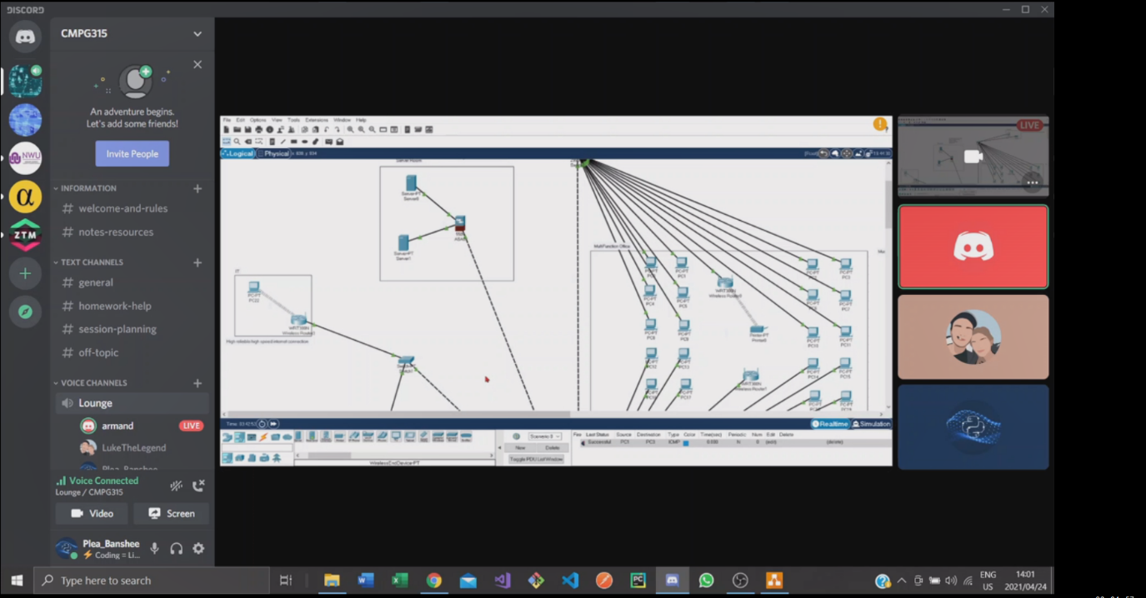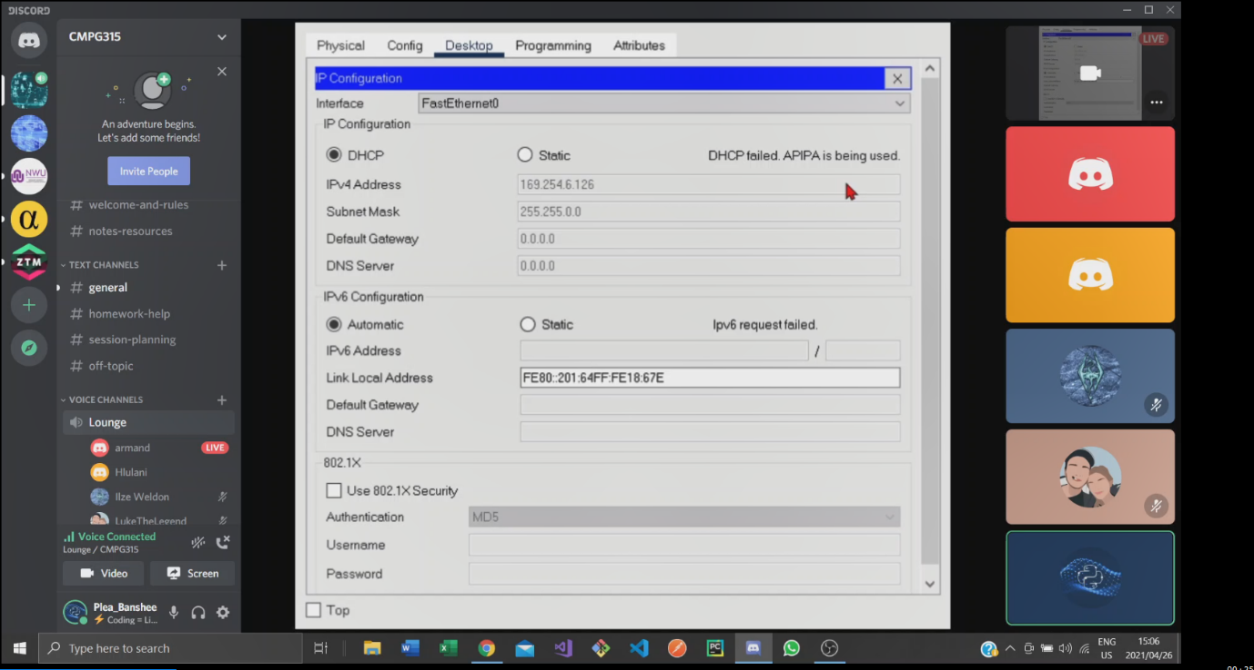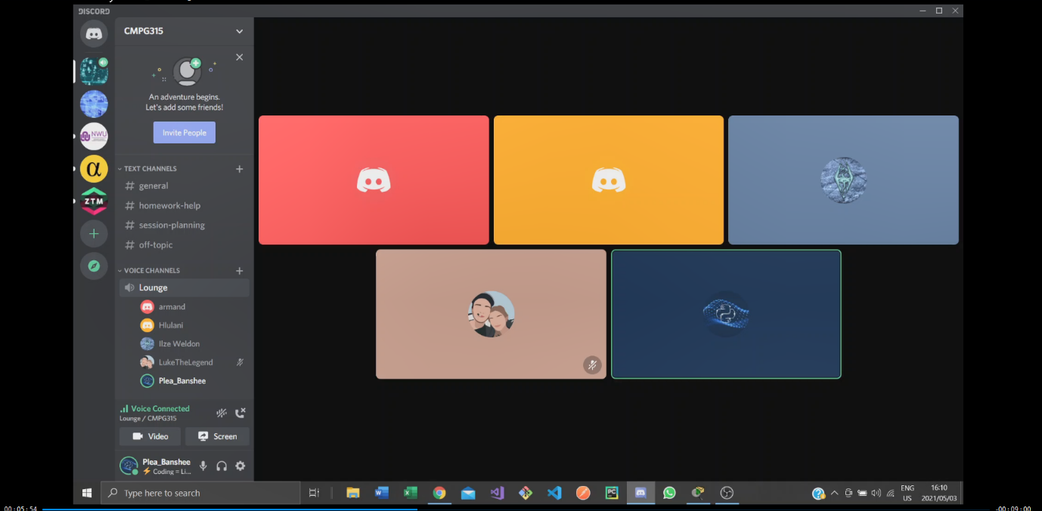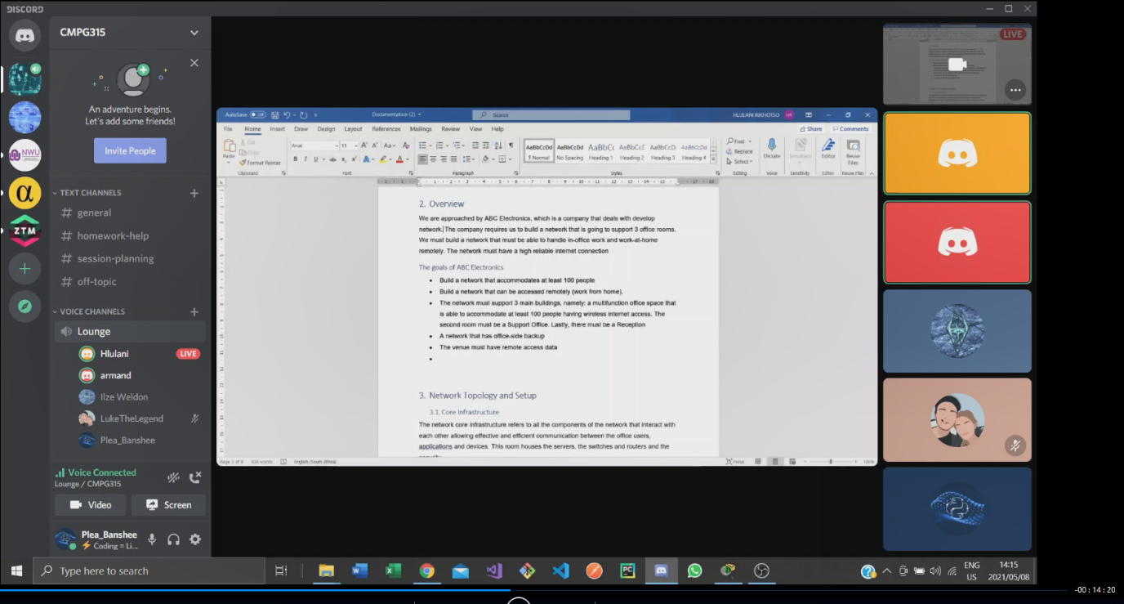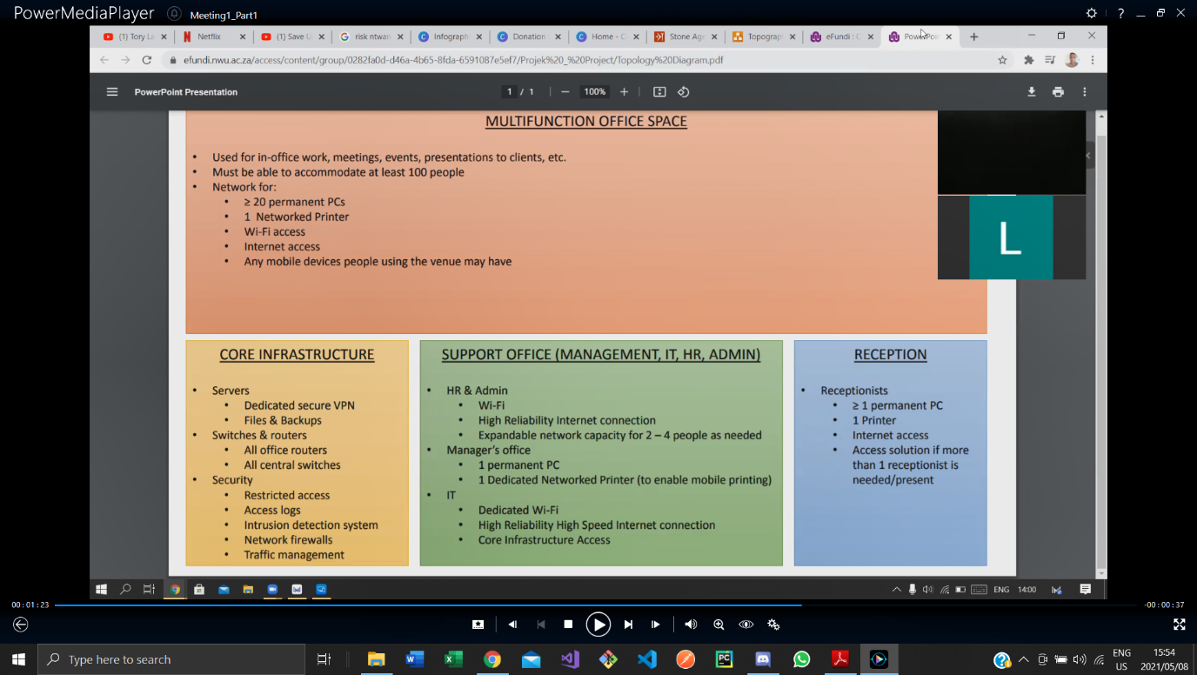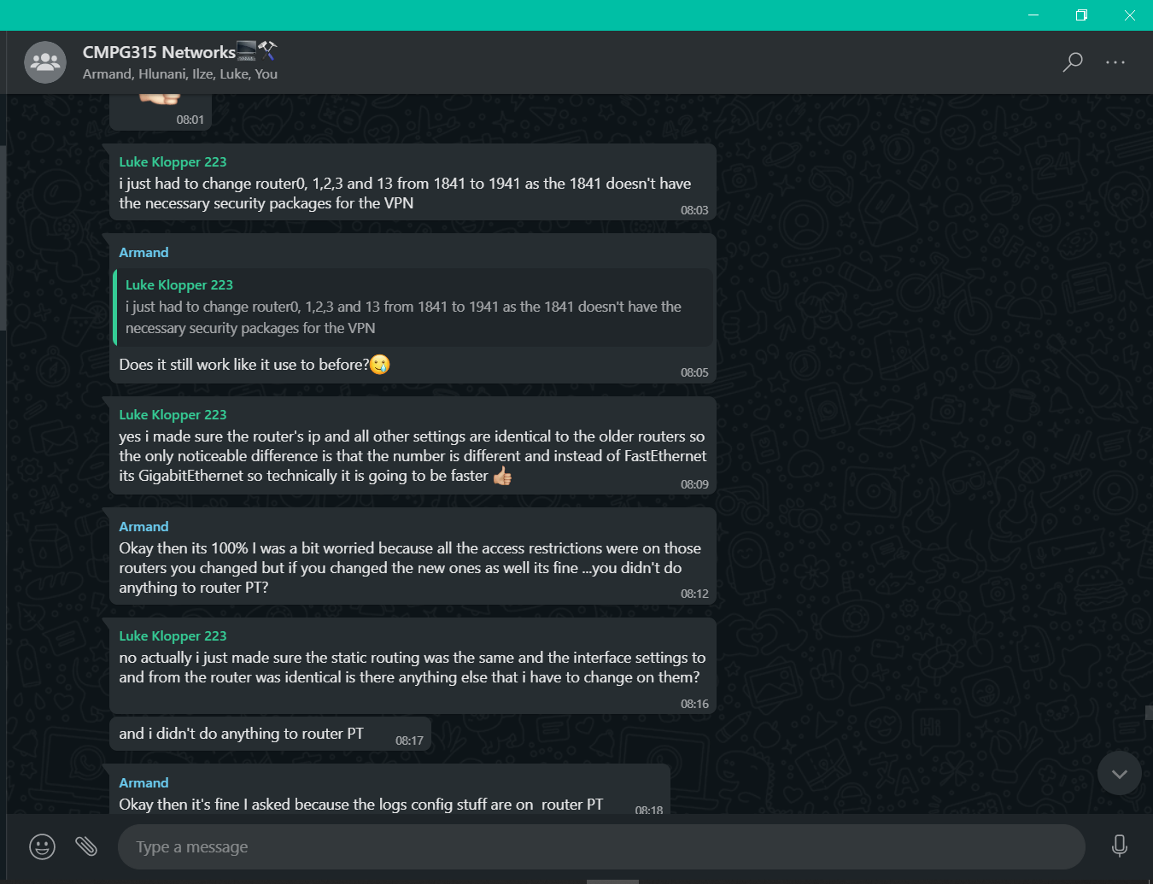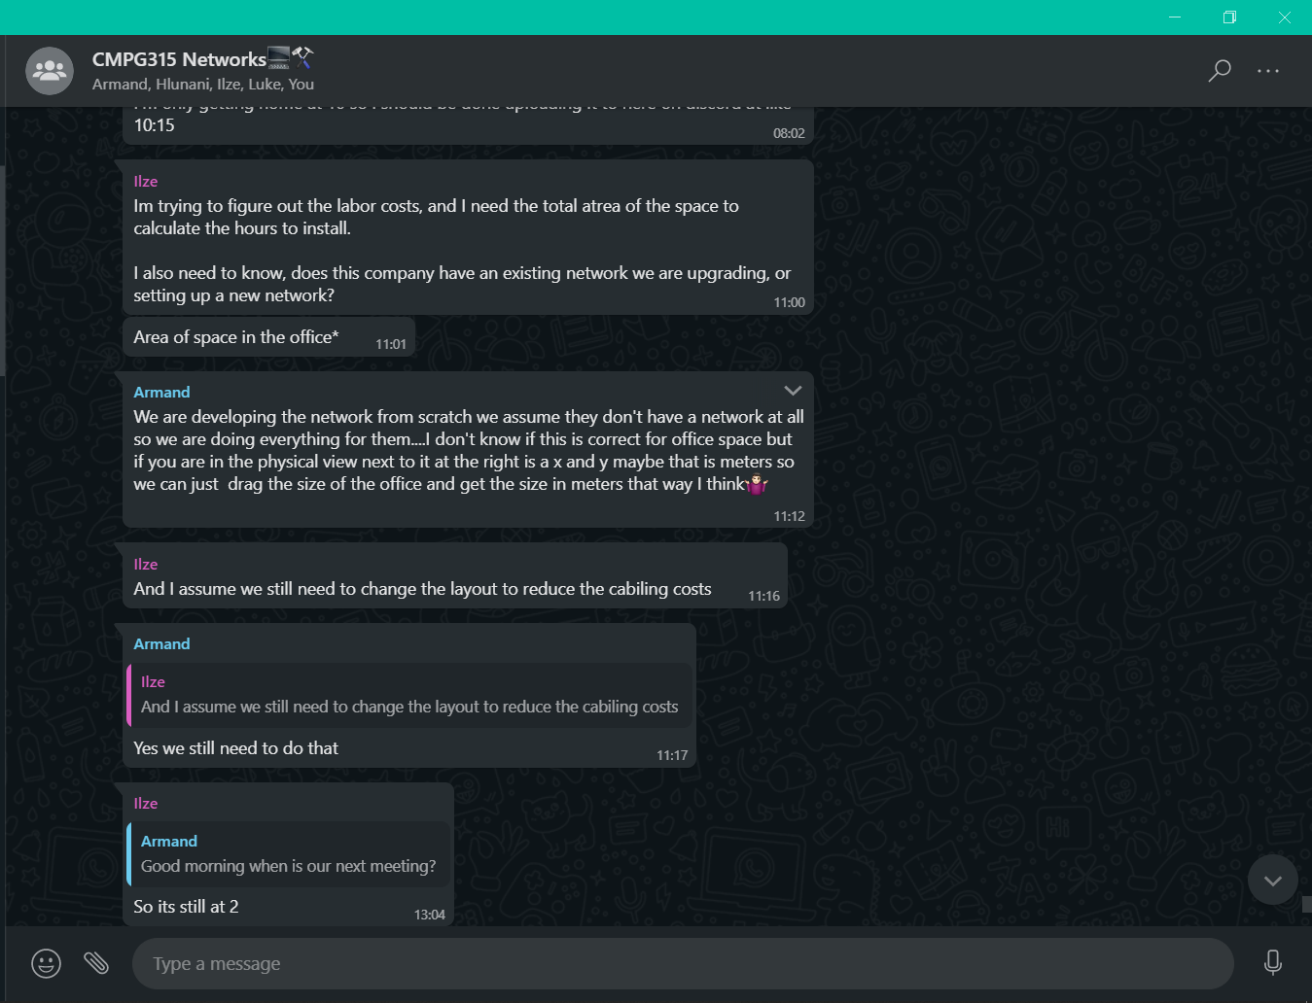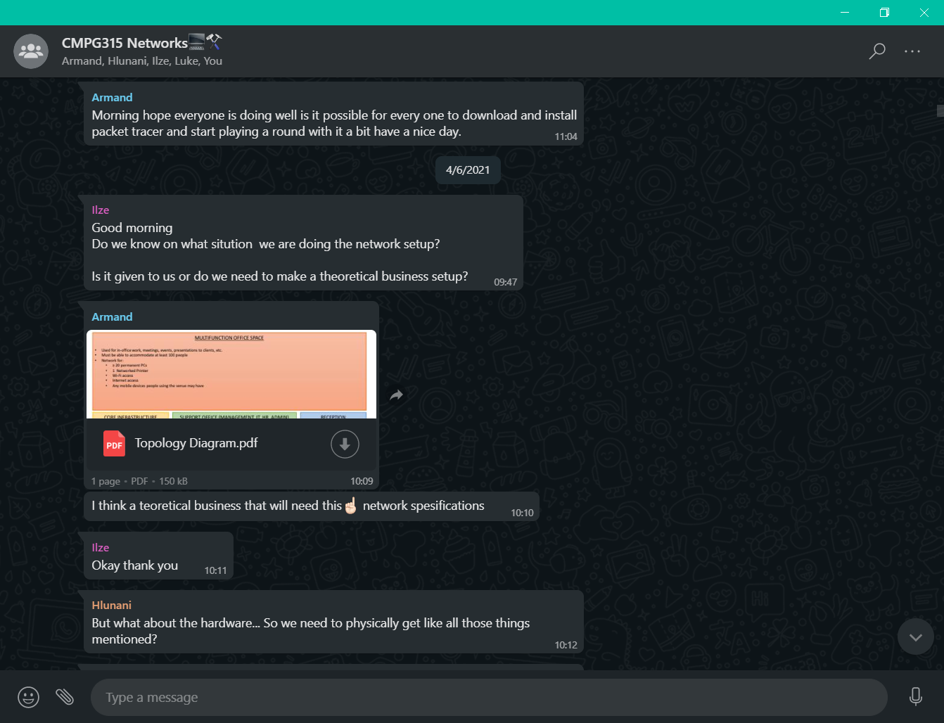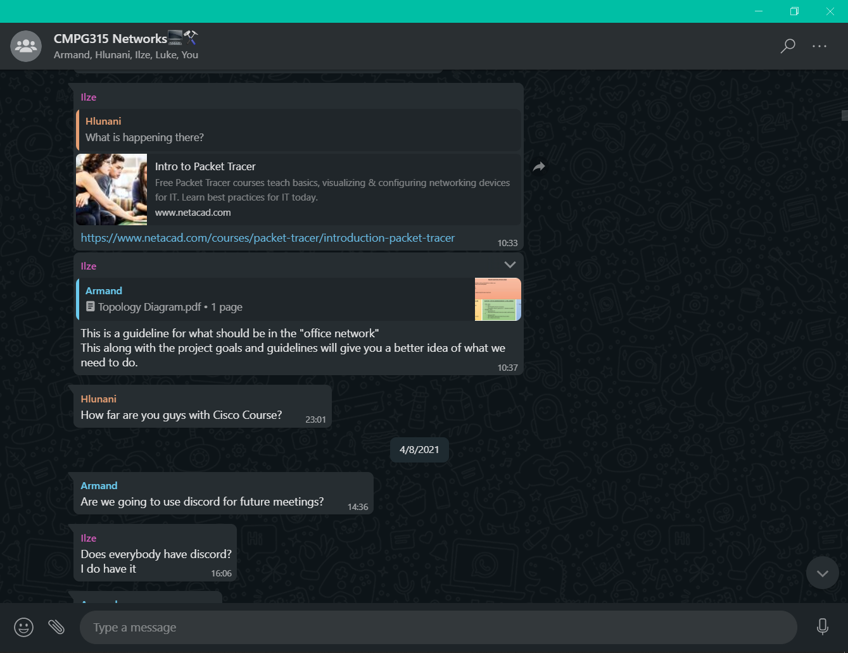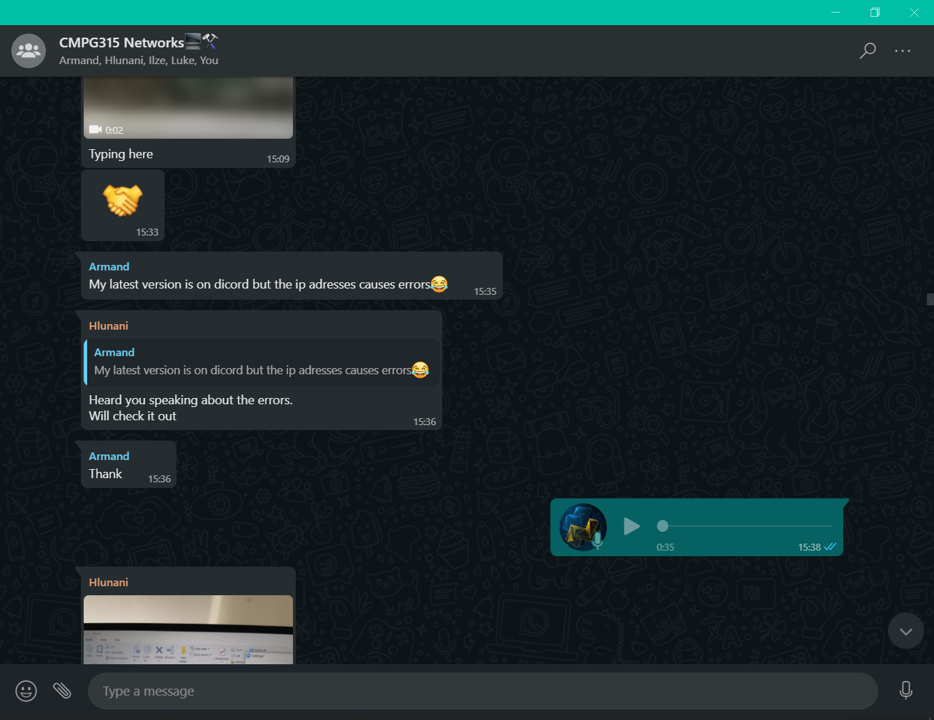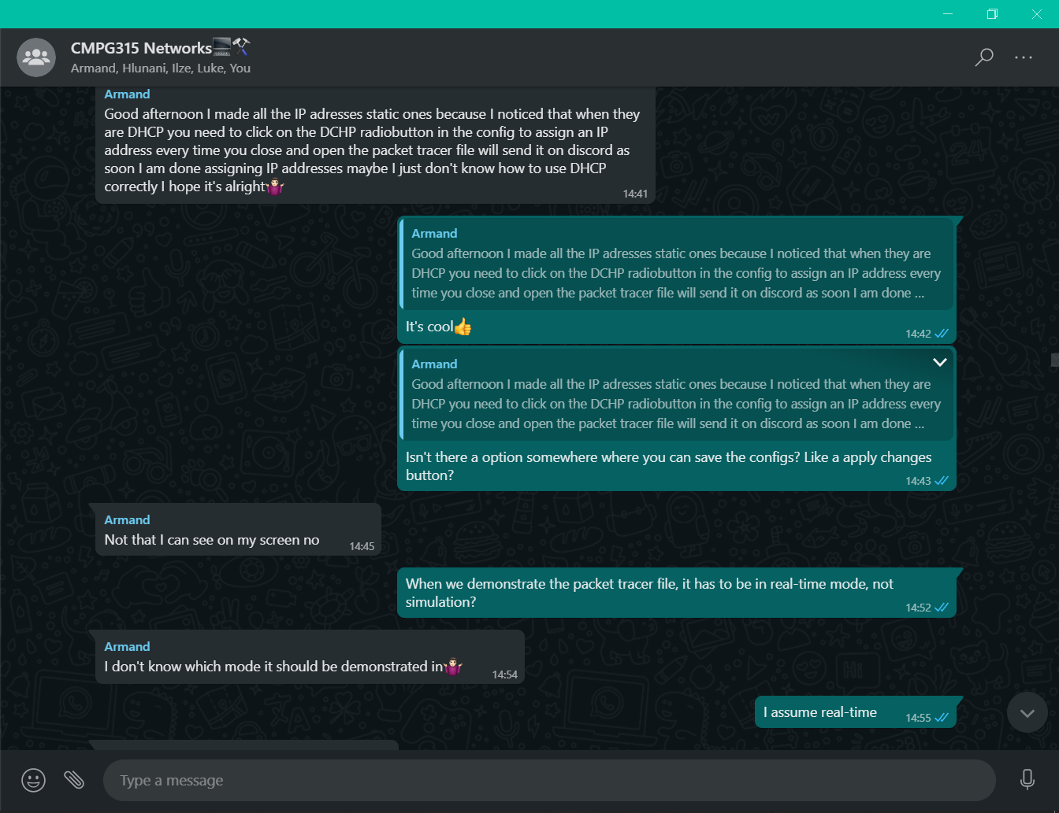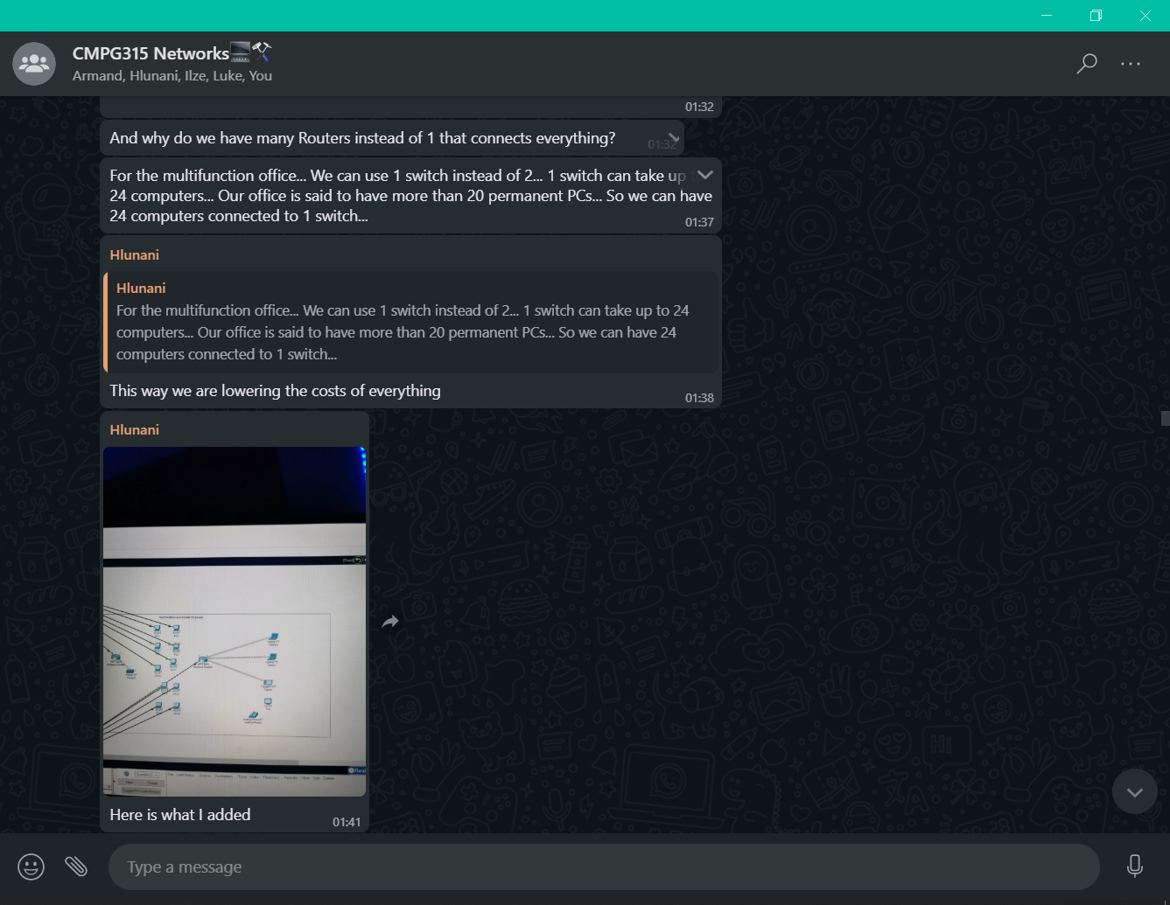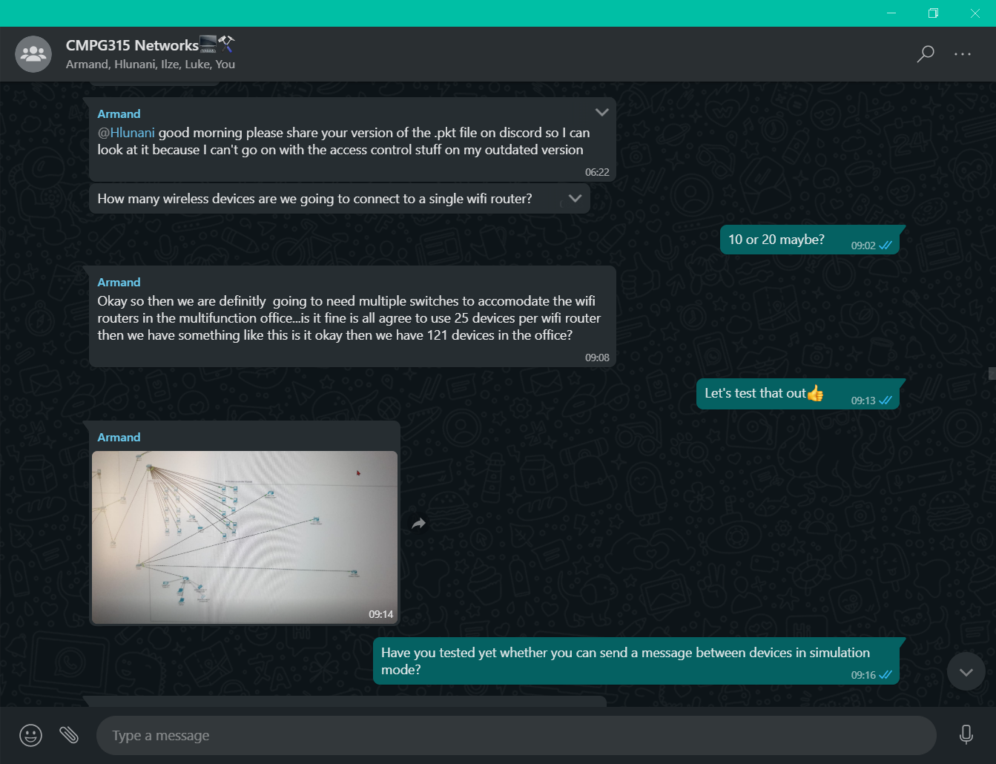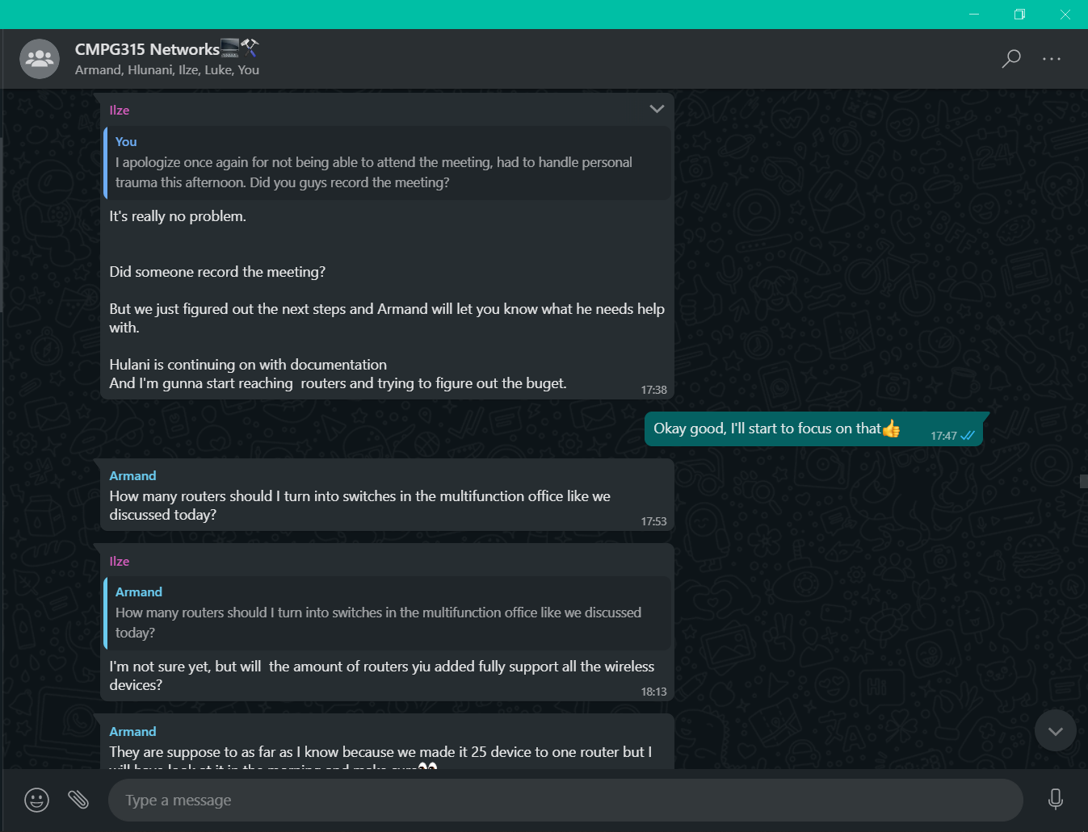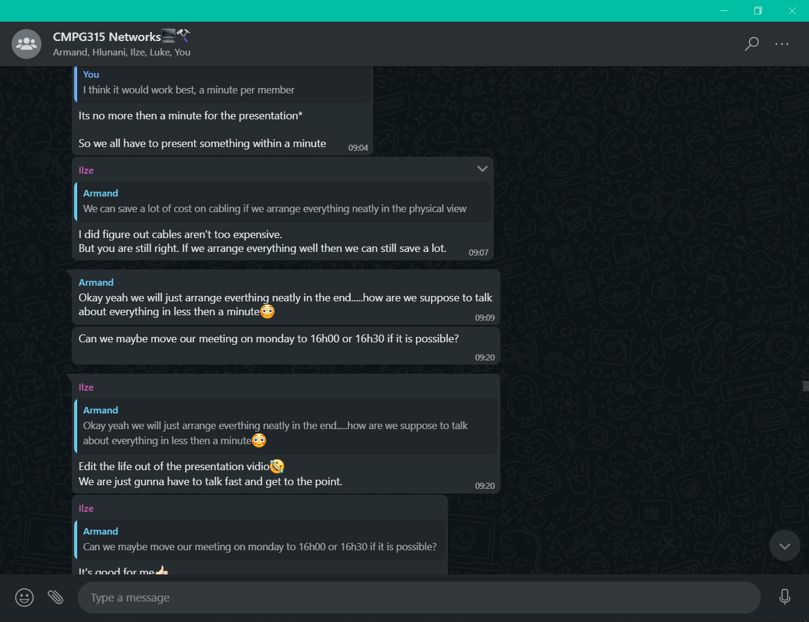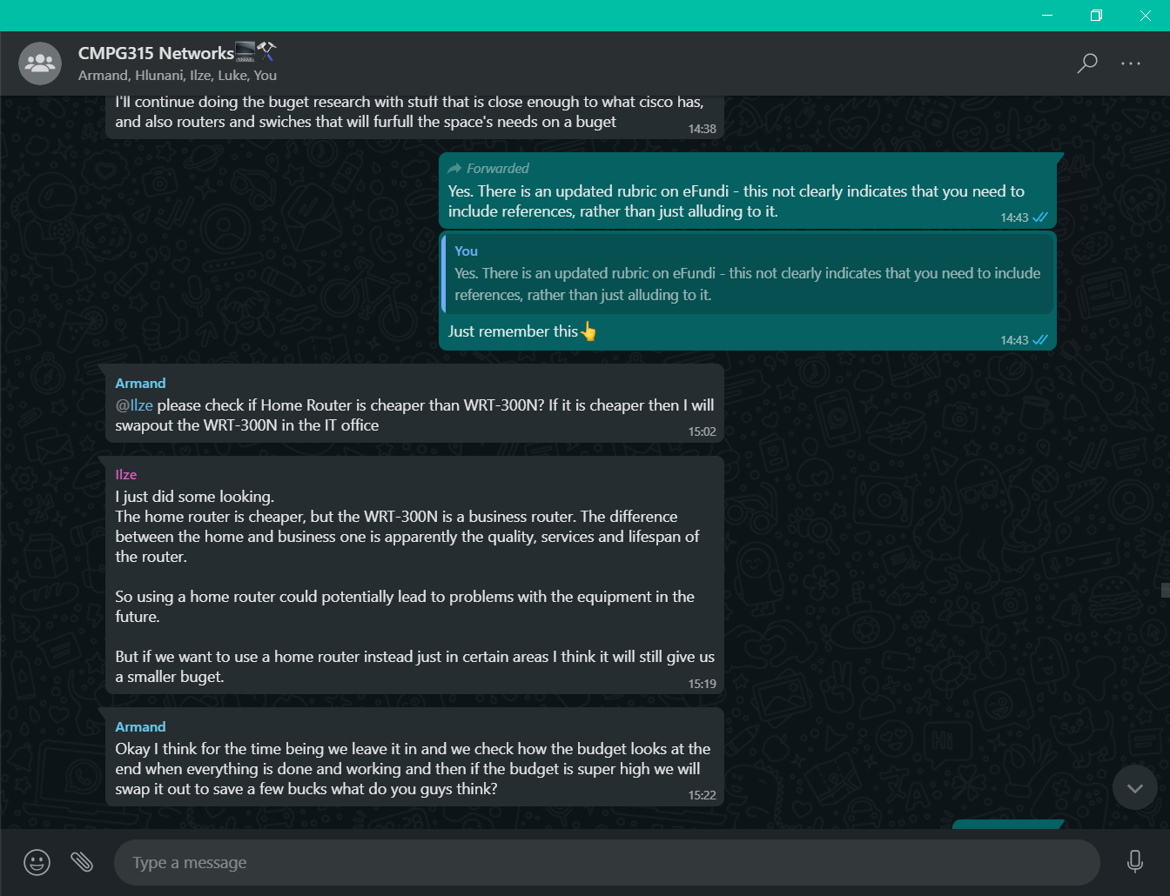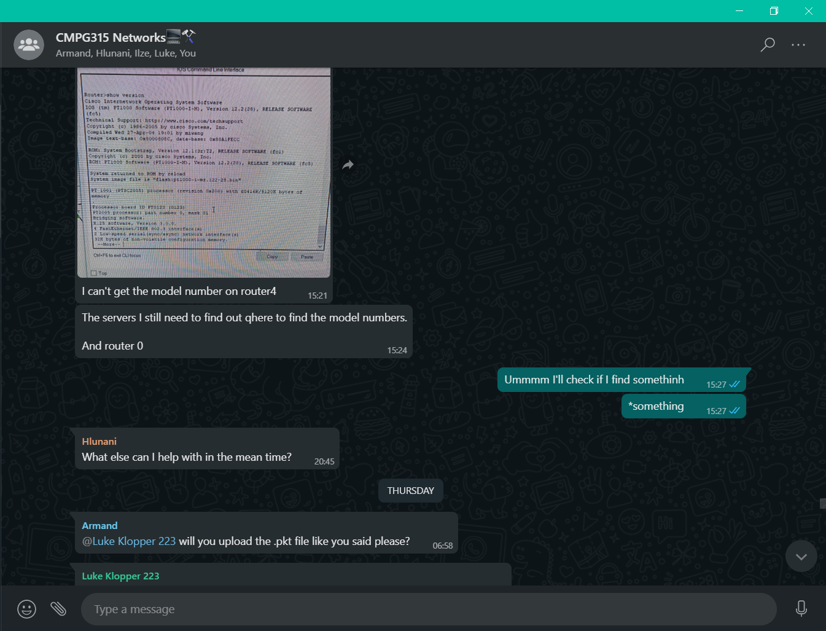

## Reflection on Remote Group work experiences

The group as a whole didn’t experience any difficulties when working remotely. There was sufficient communication which aided success of the whole project. The group was motivated each day to complete the project before the deadline. We as a group used the following: whatsapp, discord, google docs to make light work of the project. A Github Repo was created to do version control of the Packet Tracer file, and everyone had access to the Repo to download the latest version of the Packet Tracer file if mistakes were made. The link to the Github repo is provided at the end of the document.

# Budget

In this section, the budget for the whole project is going to be discussed. The following spreadsheets contain the budget of every networking component and the costs to set up the network.

### Budget overview



### Labour cost

According to PayScale (2021) the average hourly rate of a network technician is R51 an hour. According to Fixr (2021) Contractors usually estimate that it will take 30 - 40 hours to install 2,000 feet, depending on complexity, and whether it's a new or already existing network.

It will take up to 40 hours for us to set up a network in a 100m by 200m of office space. The business does not currently have an existing network setup in the office so we need to create a new network. So the total labour cost for 40 hours is R2040

### The cable Budget

In our network we used mainly two types of cables to lay out our network. Copper straight through and copper cross over cables. Every cable connection needed RJ45 connectors on each end.

|  |  |  |  |
| --- | --- | --- | --- |
| **Name** | **Average Price** | **Usage** | **Link** |
| copper straight through | R400 per 100m | R4 per 1m | [Takealot](https://www.takealot.com/coaxial-bulk-roll-cable/PLID72051607) |
| copper cross over | R400 per 100m | R4 per 1m | [Takealot](https://www.takealot.com/patented-hi-speed-twisted-pair-100-base-tx-cat-6e-ethernet-cable/PLID71638642?gclid=CjwKCAjw7diEBhB-EiwAskVi17FBOMmZqcdbsspvEW3oL-0bA2CLQ7SRIycKeVdCavjtJhZwfWbP_BoCyvEQAvD_BwE&gclsrc=aw.ds) |
| RJ45 Connectors | R100 for 12 | R16 for 2 | [Takealot](https://www.takealot.com/rj45-connector-network-utp-tip-12-pack/PLID45283617?gclid=CjwKCAjw-e2EBhAhEiwAJI5jg-uEWtrIxdpGTmxEBpgOGrI6iA_Wdj5ijbCc0VdMfhN3Oa6RDUr9eRoCnFUQAvD_BwE&gclsrc=aw.ds) |
| Total cost for cables and Connectors | R 8203,18 | | |

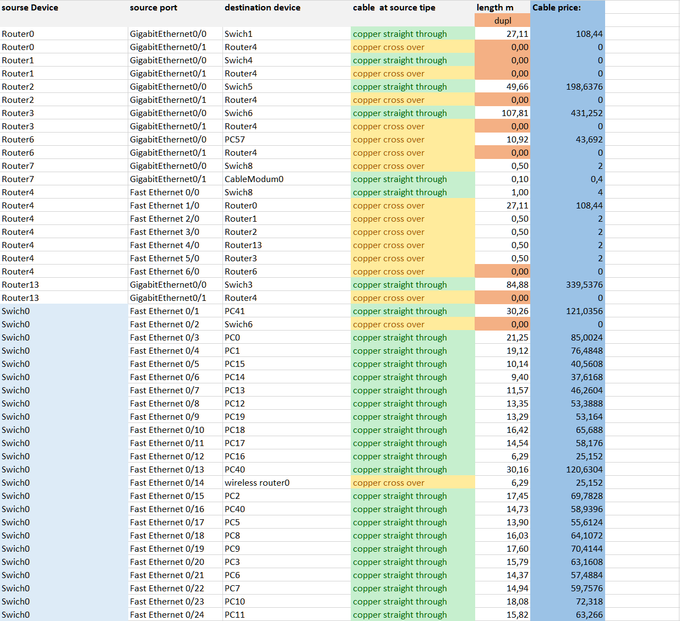

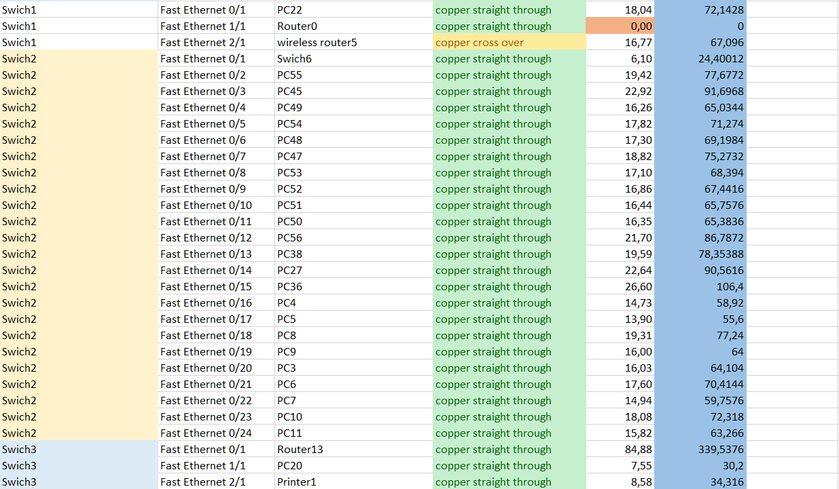



### Hardware

Listed down below is all the hardware we use for the network and the reasons for use.

|  |  |  |
| --- | --- | --- |
| **Name Price** | **Purchase from shop:** | **Reasons for use** |
| **Trendnet TWG-431BR - Gigabit Multi-WAN VPN Business Router**  **R2704** | [Takealot](https://www.trendnet.com/products/business-router/gigabit-multi-wan-vpn-business-router-TWG-431BR)  https://www.takealot.com/trendnet-twg-431br-gigabit-multi-wan-vpn-business-router/PLID71782230?gclid=CjwKCAjw-e2EBhAhEiwAJI5jg1V-_FX2sBENKEcPNoAQVmK5bYfUiCM-NnTrA7agsG2rIl4NSBCADhoCrEIQAvD_BwE&gclsrc=aw.ds | * Same quality as the cisco routers but more affordable * Has VPN support * (CLI) Management |
| **Cisco DPC3008 (Comcast, TWC, Cox Version) DOCSIS 3.0 Cable Modem**  **R877** | [PCLinkshop](https://pclinkshop.com/products/cisco-dpc3008-comcast-twc-cox-version-docsis-3-0-cable-modem-renewed)  https://pclinkshop.com/products/cisco-dpc3008-comcast-twc-cox-version-docsis-3-0-cable-modem-renewed | * The same model used in cisco PT * No other cable modems compared where cost effective and sufficient |
| **TPLINK 24-Port Gigabit Easy Smart Switch, 24 10/100/1000Mbps RJ45 ports**  **R2060** | [server warehouse](https://www.server-warehouse.co.za/tl-sg1024de.html)  https://www.server-warehouse.co.za/tl-sg1024de.html | * Same quality as the cisco Switch but more affordable * Smart Managed |
| **Ubiquiti EdgeSwitch XP 5-Port PoE**  **R1725** | [server warehouse](https://www.server-warehouse.co.za/es-5xp.html)  https://www.server-warehouse.co.za/es-5xp.html | * Same quality as the cisco Switch but more affordable * Managed |
| **TPLINK 16-Port Gigabit Easy Smart Switch, 16 10/100/1000Mbps RJ45 ports**  **R1614** | [server warehouse](https://www.server-warehouse.co.za/tl-sg1016de.html)  https://www.server-warehouse.co.za/tl-sg1016de.html | * Same quality as the cisco Switch but more affordable * Smart Managed |
| **Cisco-Linksys WRT300N Wireless-N Broadband Router**  **R1334.18** | [Amazon](https://www.amazon.com/gp/product/B00TCU295S/ref=as_li_ss_tl?ie=UTF8&linkCode=sl1&tag=business-routers-20&linkId=90b6e073061534647516f8425d8b20b1)  https://www.amazon.com/gp/product/B00TCU295S/ref=as_li_ss_tl?ie=UTF8&linkCode=sl1&tag=business-routers-20&linkId=90b6e073061534647516f8425d8b20b1 | * The same model used in cisco PT * No other Wireless Routers compared where cost effective and sufficient |
| **Server** | The company has an existing server they used for backups of important files and data and to access the cloud to save this data. | |

### Contingency

To account for cost uncertainty and to guarantee that the budget is not exceeded at a certain confidence level, a reserve fund needs to be added to your base cost estimate called contingency (Ghorbani, 2021). These funds are used for when hardware costs exceed expected costs or when unexpected network purchases need to be made.

According to Ghorbani (2021) the contingency is calculated as follows:

contingency = 15% X Base cost estimate

|  |  |
| --- | --- |
| **Base cost Estimate calculation** | |
| Hardware | 49205.08 |
| Cables | 8203,18 |
| Labour | 2040.00 |
| **Total Base cost Estimate** | **59448.26** |
| 15% Contingency = | R8917.32 |

# References

Amazon.com. 2021. TRENDnet AC3200 Gigabit Tri-Band Wi-Fi Router, DD-WRT Compatible, Tri-Band, Smart Connect, 1GHz dual core processor, VPN, TEW-828DRU. Available at: <<https://www.amazon.com/gp/product/B00TCU295S/ref=as_li_ss_tl?ie=UTF8&linkCode=sl1&tag=business-routers-20&linkId=90b6e073061534647516f8425d8b20b1>> [Accessed 12 May 2021].

Fixr.com. 2021. *Computer Network Installation Cost | Internet Set Up Cost*. [online] Available at: <<https://www.fixr.com/costs/hardwired-computer-network>> [Accessed 12 May 2021].

Ghorbani, S., 2021. *How Cost Contingency is Calculated?*. [online] Project Control Academy. Available at: <<https://www.projectcontrolacademy.com/cost-contingency-calculation>> [Accessed 12 May 2021].

Payscale.com. 2021. *Cisco Networking Hourly Rate in South Africa | PayScale*. [online] Available at: <<https://www.payscale.com/research/ZA/Skill=Cisco_Networking/Hourly_Rate>> [Accessed 12 May 2021].

Pclinkshop.com. 2021. Cisco Dpc3008 (Comcast, Twc, Cox Version) Docsis 3.0 Cable Modem (Renewed). Available at: <<https://pclinkshop.com/products/cisco-dpc3008-comcast-twc-cox-version-docsis-3-0-cable-modem-renewed>> [Accessed 12 May 2021].

Server-warehouse.co.za. TPLINK 16-Port Gigabit Easy Smart Switch, 16 10/100/1000Mbps RJ45 ports. Available at: <<https://www.server-warehouse.co.za/tl-sg1016de.html>> [Accessed 12 May 2021].

Server-warehouse.co.za. 2021. TPLINK 24-Port Gigabit Easy Smart Switch, 24 10/100/1000Mbps RJ45 ports. Available at: <<https://www.server-warehouse.co.za/tl-sg1024de.html>> [Accessed 12 May 2021].

Server-warehouse.co.za. 2021. Ubiquiti EdgeSwitch XP 5-Port PoE. Available at: <<https://www.server-warehouse.co.za/es-5xp.html>> [Accessed 12 May 2021].

Trendnet.com. 2021. Gigabit Multi-WAN VPN Business Router TWG-431BR. Available at: <<https://www.trendnet.com/products/business-router/gigabit-multi-wan-vpn-business-router-TWG-431BR>> [Accessed 12 May 2021].

**Github Repo for Packet Tracer:** [**https://github.com/PleaBanshee/CMPG315_Packet_Tracer**](https://github.com/PleaBanshee/CMPG315_Packet_Tracer)